**CREATE A WEB PROJECT USING MAVEN**

**FOLDER STRUCTURE**

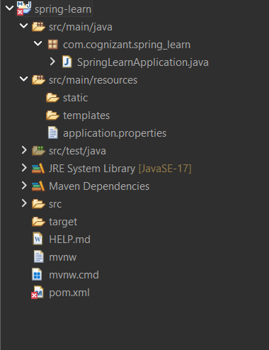

**SpringLearnApplication.java**

package com.cognizant.spring_learn;

import org.slf4j.Logger;

import org.slf4j.LoggerFactory;

import org.springframework.boot.SpringApplication;

import org.springframework.boot.autoconfigure.SpringBootApplication;

*@SpringBootApplication*

public class SpringLearnApplication {

private static final Logger ***LOGGER*** = LoggerFactory.*getLogger*(SpringLearnApplication.class);

public static void main(String[] args) {

***LOGGER***.info("START");

SpringApplication.*run*(SpringLearnApplication.class, args);

***LOGGER***.info("END");

}

}

**OUTPUT**

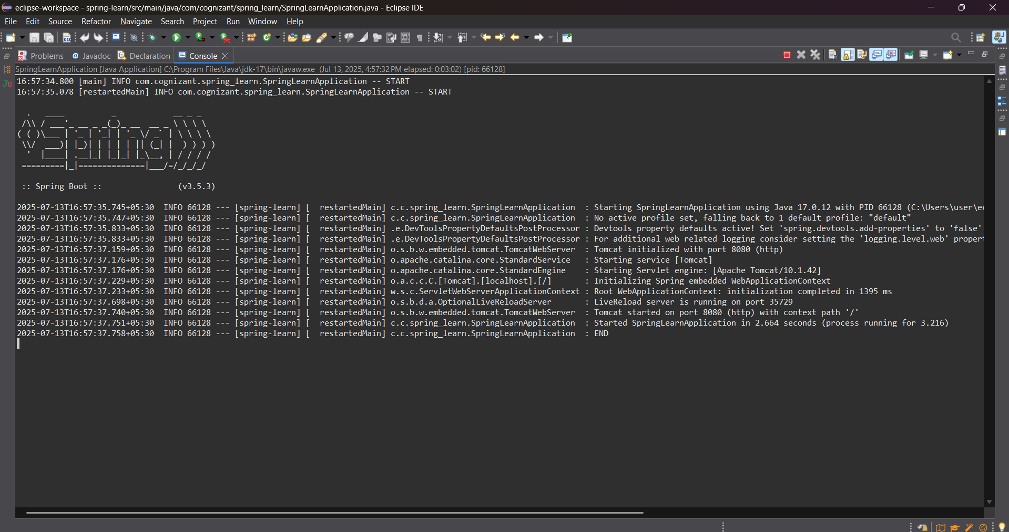

**Load Country from Spring Configuration XML**

**FOLDER STRUCTURE**

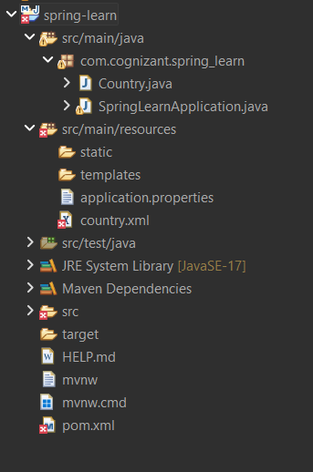

**Country.java**

package com.cognizant.spring_learn;

import org.slf4j.Logger;

import org.slf4j.LoggerFactory;

public class Country {

private static final Logger ***LOGGER*** = LoggerFactory.*getLogger*(Country.class);

private String code;

private String name;

public Country() {

***LOGGER***.debug("Inside Country Constructor.");

}

public String getCode() {

***LOGGER***.debug("Inside getCode()");

return code;

}

public void setCode(String code) {

***LOGGER***.debug("Inside setCode()");

this.code = code;

}

public String getName() {

***LOGGER***.debug("Inside getName()");

return name;

}

public void setName(String name) {

***LOGGER***.debug("Inside setName()");

this.name = name;

}

*@Override*

public String toString() {

return "Country [code=" + code + ", name=" + name + "]";

}

}

**SpringLearnApplication.java**

package com.cognizant.spring_learn;

import org.slf4j.Logger;

import org.slf4j.LoggerFactory;

import org.springframework.boot.SpringApplication;

import org.springframework.boot.autoconfigure.SpringBootApplication;

import org.springframework.context.ApplicationContext;

import org.springframework.context.support.ClassPathXmlApplicationContext;

*@SpringBootApplication*

public class SpringLearnApplication {

private static final Logger ***LOGGER*** = LoggerFactory.*getLogger*(SpringLearnApplication.class);

public static void main(String[] args) {

***LOGGER***.info("START");

SpringApplication.*run*(SpringLearnApplication.class, args);

*displayCountry*();

***LOGGER***.info("END");

}

public static void displayCountry() {

***LOGGER***.debug("Start displayCountry()");

ApplicationContext context = new ClassPathXmlApplicationContext("country.xml");

Country country = context.getBean("country", Country.class);

***LOGGER***.debug("Country : {}", country.toString());

***LOGGER***.debug("End displayCountry()");

}

}

**country.xml**

<?xml version="1.0" encoding="UTF-8"?>

<beans xmlns="http://www.springframework.org/schema/beans"

xmlns:xsi="http://www.w3.org/2001/XMLSchema-instance"

xsi:schemaLocation="

http://www.springframework.org/schema/beans

http://www.springframework.org/schema/beans/spring-beans.xsd">

<bean id="country" class="com.cognizant.spring_learn.Country">

<property name="code" value="IN" />

<property name="name" value="India" />

</bean>

</beans>

**application.properties**

spring.application.name=spring-learn

logging.level.com.cognizant=DEBUG

**OUTPUT**

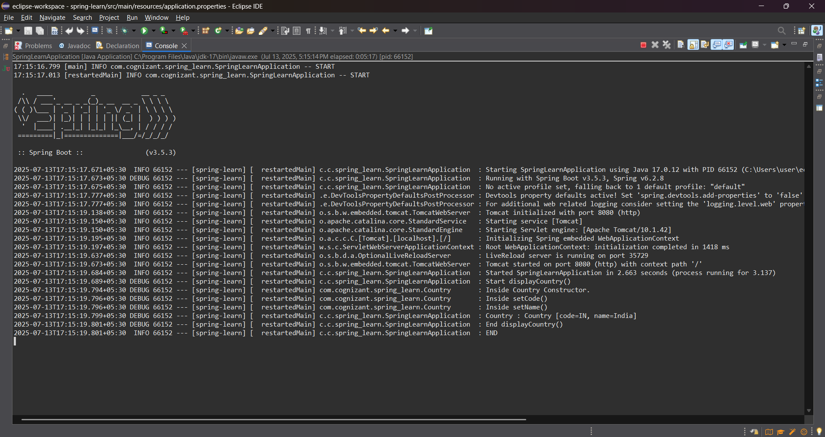

**Hello World RESTful Web Service   
FOLDER STRUCTURE**

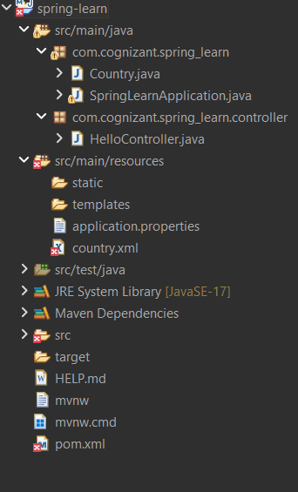

**Country.java**

package com.cognizant.spring_learn;

import org.slf4j.Logger;

import org.slf4j.LoggerFactory;

public class Country {

private static final Logger ***LOGGER*** = LoggerFactory.*getLogger*(Country.class);

private String code;

private String name;

public Country() {

***LOGGER***.debug("Inside Country Constructor.");

}

public String getCode() {

***LOGGER***.debug("Inside getCode()");

return code;

}

public void setCode(String code) {

***LOGGER***.debug("Inside setCode()");

this.code = code;

}

public String getName() {

***LOGGER***.debug("Inside getName()");

return name;

}

public void setName(String name) {

***LOGGER***.debug("Inside setName()");

this.name = name;

}

*@Override*

public String toString() {

return "Country [code=" + code + ", name=" + name + "]";

}

}

**SpringLearnApplication.java**

package com.cognizant.spring_learn;

import org.slf4j.Logger;

import org.slf4j.LoggerFactory;

import org.springframework.boot.SpringApplication;

import org.springframework.boot.autoconfigure.SpringBootApplication;

import org.springframework.context.ApplicationContext;

import org.springframework.context.support.ClassPathXmlApplicationContext;

*@SpringBootApplication*

public class SpringLearnApplication {

private static final Logger ***LOGGER*** = LoggerFactory.*getLogger*(SpringLearnApplication.class);

public static void main(String[] args) {

***LOGGER***.info("START");

SpringApplication.*run*(SpringLearnApplication.class, args);

*displayCountry*();

***LOGGER***.info("END");

}

public static void displayCountry() {

***LOGGER***.debug("Start displayCountry()");

ApplicationContext context = new ClassPathXmlApplicationContext("country.xml");

Country country = context.getBean("country", Country.class);

***LOGGER***.debug("Country : {}", country.toString());

***LOGGER***.debug("End displayCountry()");

}

}

**HelloController.java**

package com.cognizant.spring_learn.controller;

import org.slf4j.Logger;

import org.slf4j.LoggerFactory;

import org.springframework.web.bind.annotation.GetMapping;

import org.springframework.web.bind.annotation.RestController;

*@RestController*

public class HelloController {

private static final Logger ***LOGGER*** = LoggerFactory.*getLogger*(HelloController.class);

*@GetMapping*("/hello")

public String sayHello() {

***LOGGER***.info("START");

String response = "Hello World!!";

***LOGGER***.info("END");

return response;

}

}

**application.properties**

spring.application.name=spring-learn

logging.level.com.cognizant=DEBUG

server.port=8083

**OUTPUT – (BROWSER)**

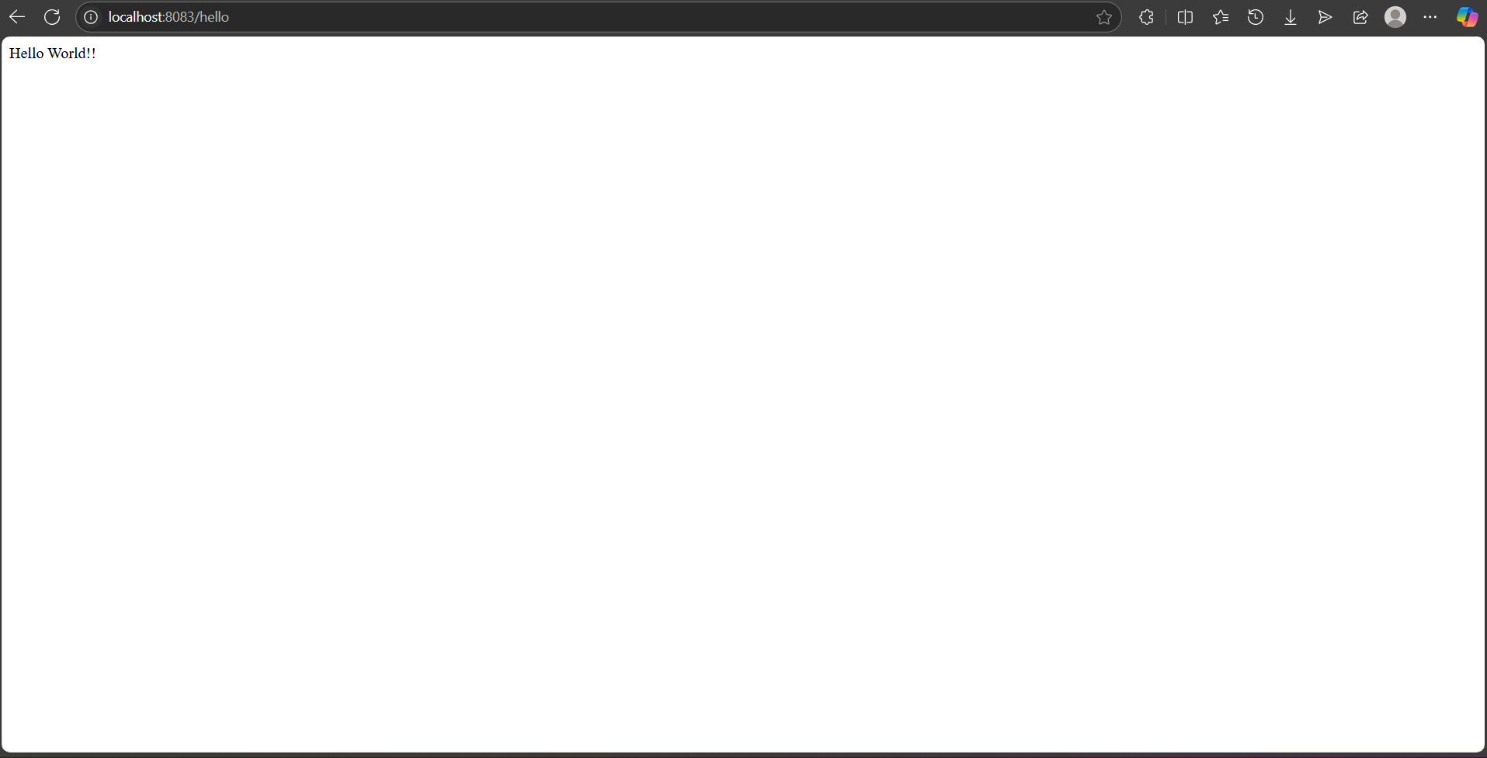

**OUPUT – (POSTMAN GET REQUEST)**

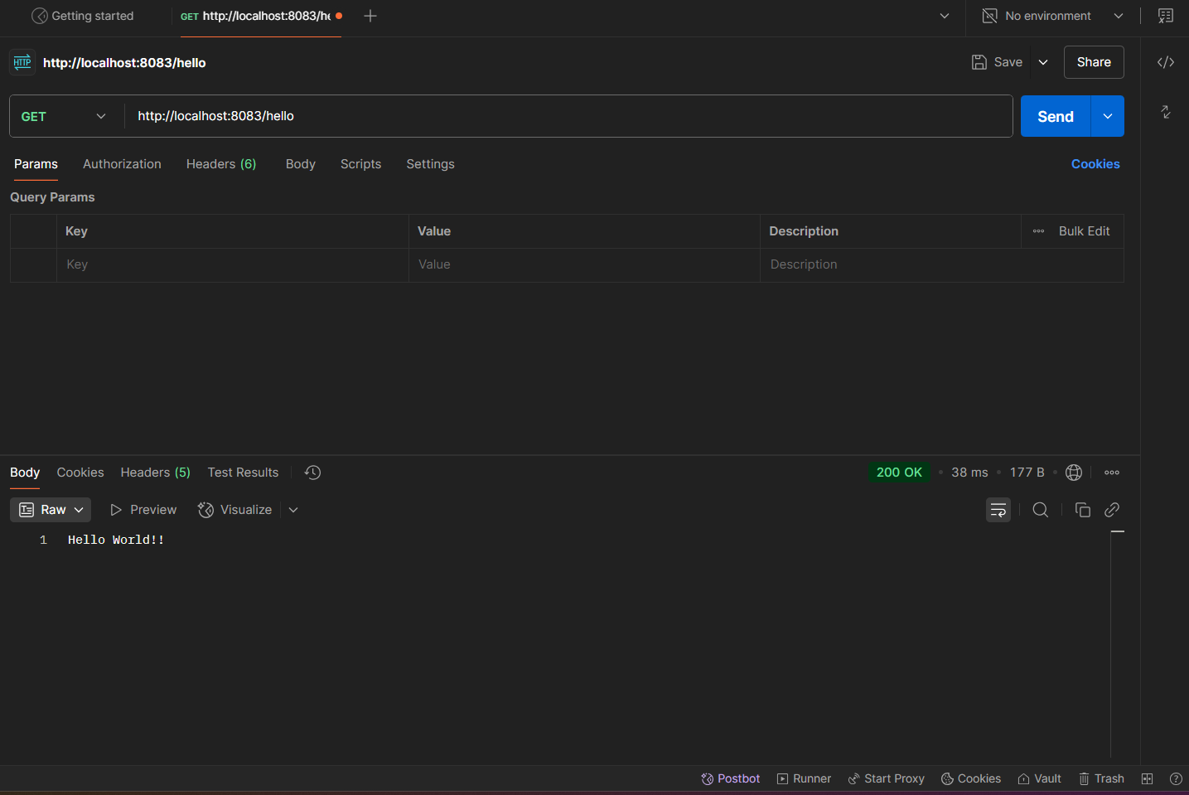

**REST - Country Web Service**   
**FOLDER STRUCTURE**

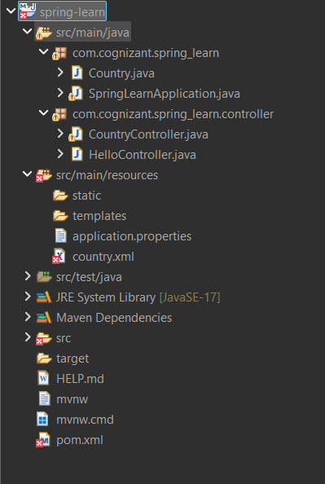

**CountryController.java**

package com.cognizant.spring_learn.controller;

import org.slf4j.Logger;

import org.slf4j.LoggerFactory;

import org.springframework.context.ApplicationContext;

import org.springframework.context.support.ClassPathXmlApplicationContext;

import org.springframework.web.bind.annotation.RequestMapping;

import org.springframework.web.bind.annotation.RestController;

import com.cognizant.spring_learn.Country;

*@RestController*

public class CountryController {

private static final Logger *LOGGER* = LoggerFactory.*getLogger*(CountryController.class);

*@RequestMapping*("/country")

public Country getCountryIndia() {

*LOGGER*.info("START");

ApplicationContext context = new ClassPathXmlApplicationContext("country.xml");

Country country = context.getBean("country", Country.class);

*LOGGER*.info("END");

return country;

}

}

**country.xml**

<?xml version="1.0" encoding="UTF-8"?>

<beans xmlns="http://www.springframework.org/schema/beans"

xmlns:xsi="http://www.w3.org/2001/XMLSchema-instance"

xsi:schemaLocation="

http://www.springframework.org/schema/beans

http://www.springframework.org/schema/beans/spring-beans.xsd">

<bean id="country" class="com.cognizant.spring_learn.Country">

<property name="code" value="IN" />

<property name="name" value="India" />

</bean>

</beans>

**OUTPUT – (BROWSER BASED)**

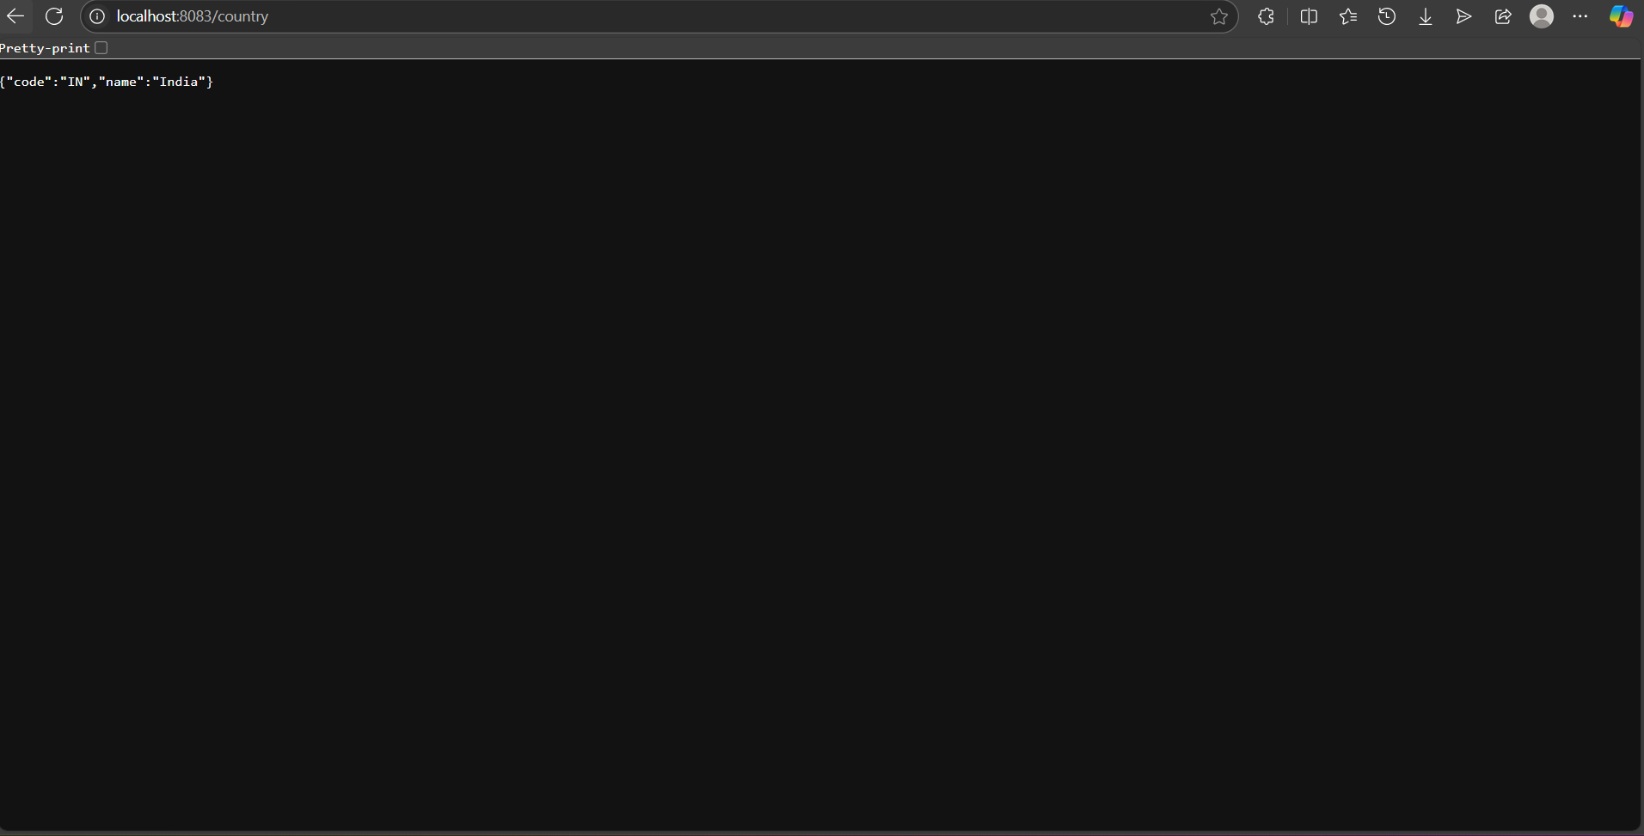

**OUTPUT-(POSTMAN GET REQUEST)**

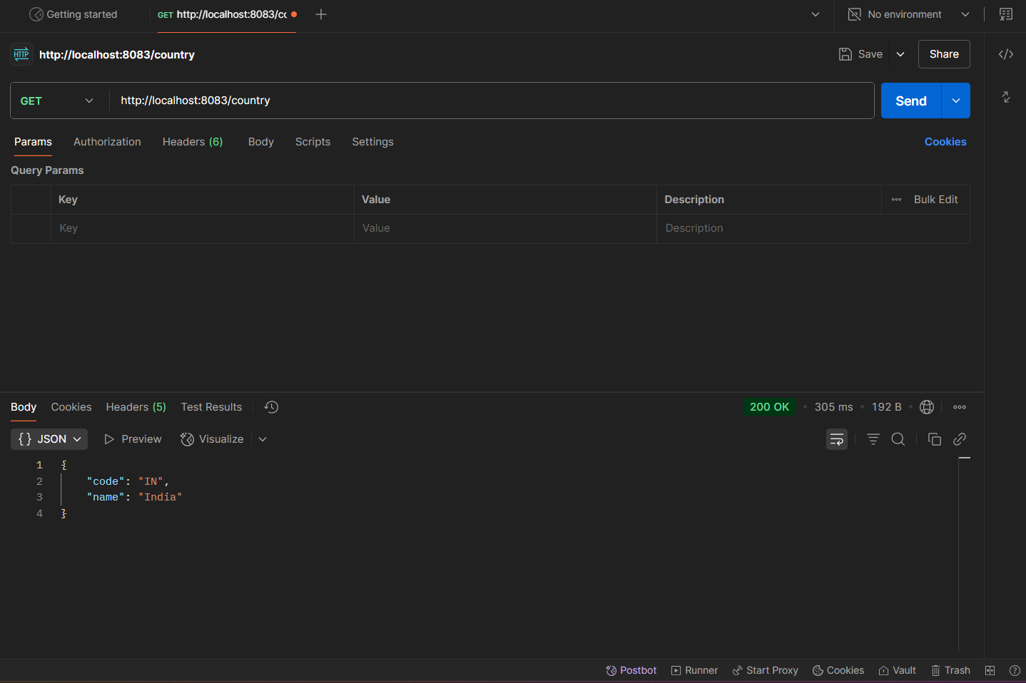

**REST - Get country based on country code   
FOLDER STRUCTURE**

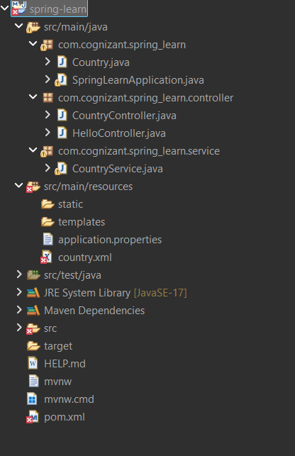

**CountryService.java**

package com.cognizant.spring_learn.service;

import java.util.List;

import org.springframework.context.ApplicationContext;

import org.springframework.context.support.ClassPathXmlApplicationContext;

import org.springframework.stereotype.Service;

import com.cognizant.spring_learn.Country;

*@Service*

public class CountryService {

public Country getCountry(String code) {

ApplicationContext context = new ClassPathXmlApplicationContext("country.xml");

List<Country> countryList = (List<Country>) context.getBean("countryList");

return countryList.stream()

.filter(country -> country.getCode().equalsIgnoreCase(code))

.findFirst()

.orElse(null); // or throw custom exception if not found

}

}

**CountryController.java**

package com.cognizant.spring_learn.controller;

import org.slf4j.Logger;

import org.slf4j.LoggerFactory;

import org.springframework.beans.factory.annotation.Autowired;

import org.springframework.web.bind.annotation.*;

import com.cognizant.spring_learn.Country;

import com.cognizant.spring_learn.service.CountryService;

*@RestController*

public class CountryController {

private static final Logger ***LOGGER*** = LoggerFactory.*getLogger*(CountryController.class);

*@Autowired*

private CountryService countryService;

*@GetMapping*("/countries/{code}")

public Country getCountry(*@PathVariable* String code) {

***LOGGER***.info("START");

Country country = countryService.getCountry(code);

***LOGGER***.info("END");

return country;

}

}

**country.xml**

<?xml version="1.0" encoding="UTF-8"?>

<beans xmlns="http://www.springframework.org/schema/beans"

xmlns:xsi="http://www.w3.org/2001/XMLSchema-instance"

xmlns:util="http://www.springframework.org/schema/util"

xsi:schemaLocation="

http://www.springframework.org/schema/beans

https://www.springframework.org/schema/beans/spring-beans.xsd

http://www.springframework.org/schema/util

https://www.springframework.org/schema/util/spring-util.xsd">

<bean id="in" class="com.cognizant.spring_learn.Country">

<property name="code" value="IN" />

<property name="name" value="India" />

</bean>

<bean id="us" class="com.cognizant.spring_learn.Country">

<property name="code" value="US" />

<property name="name" value="United States" />

</bean>

<bean id="cn" class="com.cognizant.spring_learn.Country">

<property name="code" value="CN" />

<property name="name" value="China" />

</bean>

<util:list id="countryList">

<ref bean="in" />

<ref bean="us" />

<ref bean="cn" />

</util:list>

</beans>

**OUTPUT-[CONSOLE]**

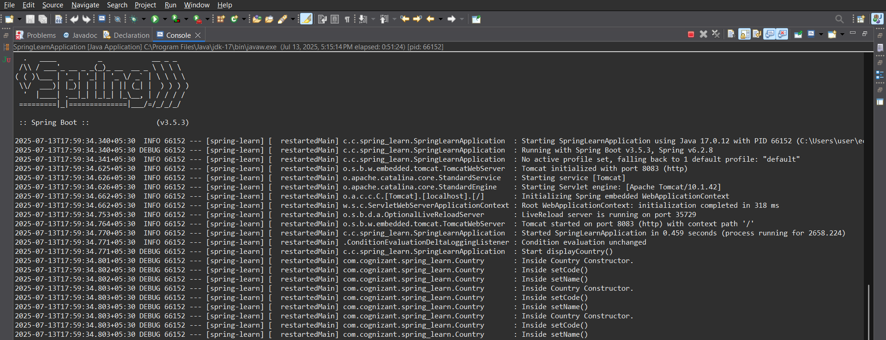

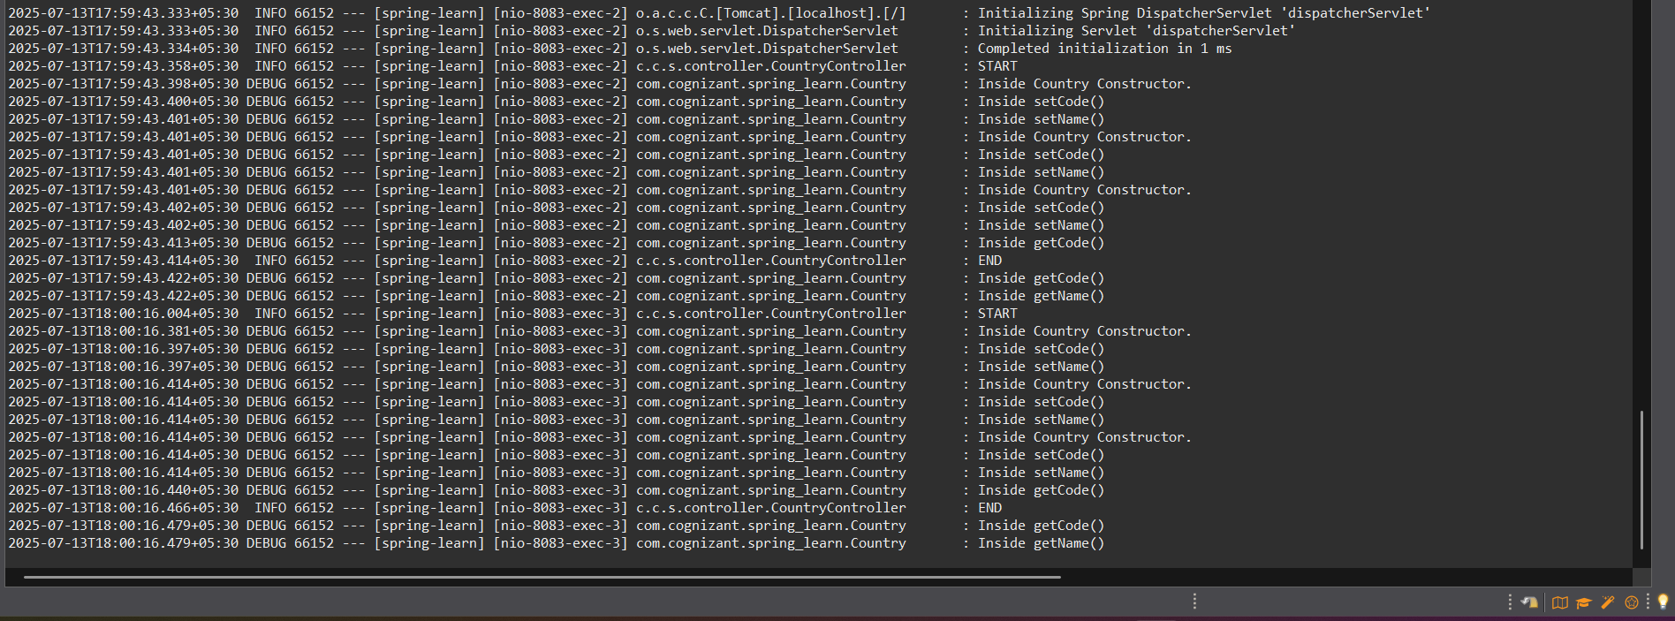

**OUTPUT-[BROWSER]**

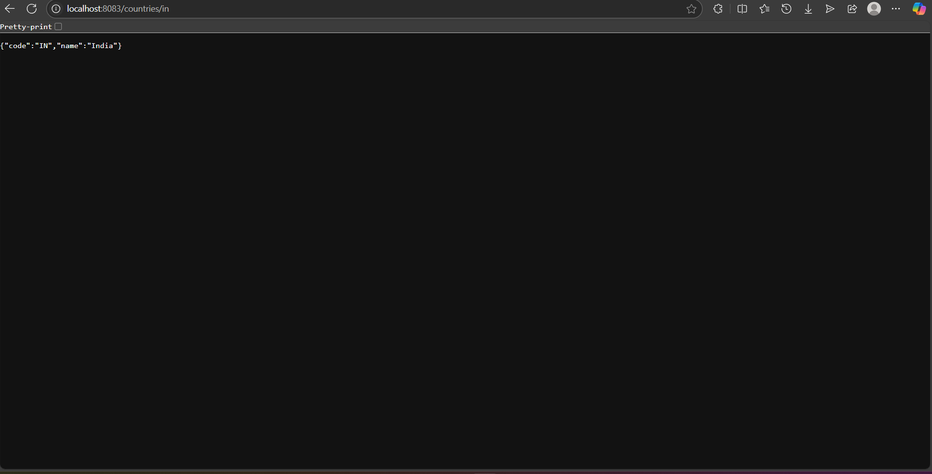

**OUTPUT –[POSTMAN]**

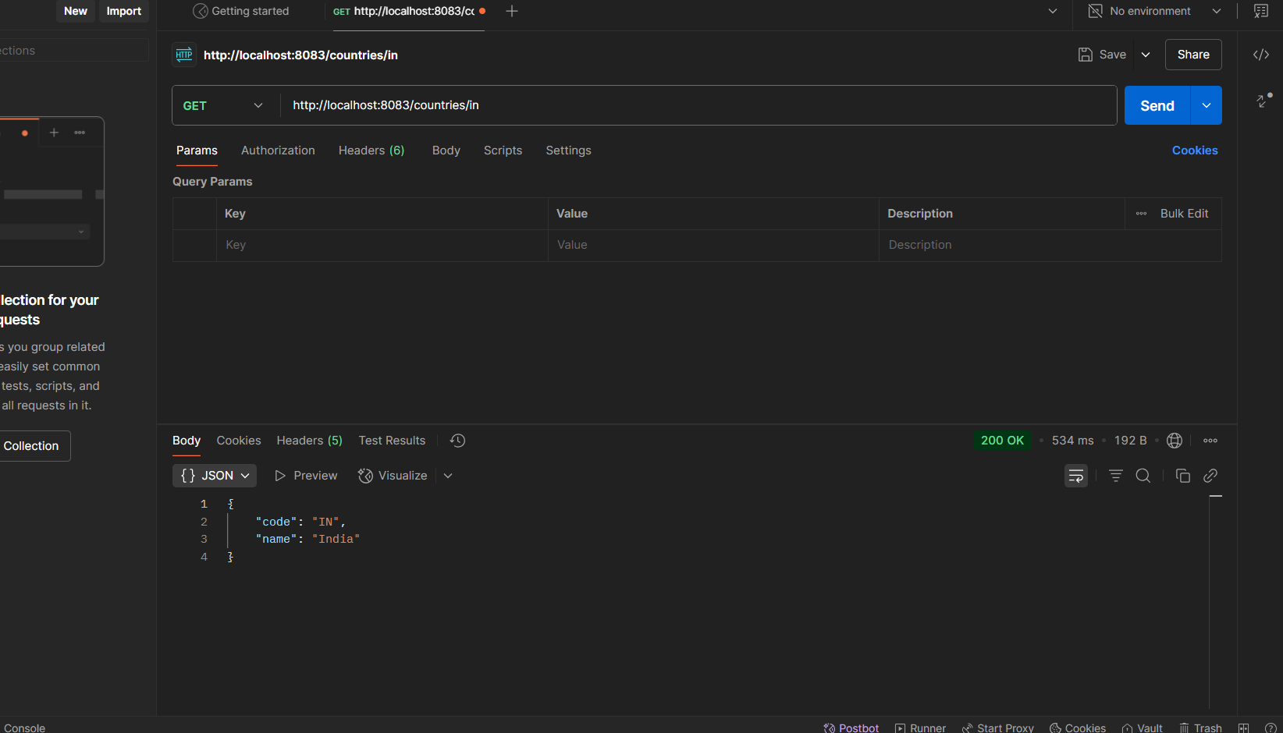

**Create authentication service that returns JWT**   
**FOLDER STRUCTURE**

**TOKEN GENERATION**

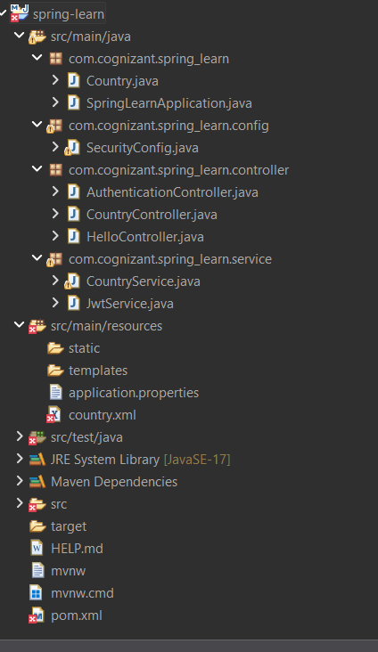

**SpringLearnApplication.java**

package com.cognizant.spring_learn;

import org.springframework.boot.SpringApplication;

import org.springframework.boot.autoconfigure.SpringBootApplication;

*@SpringBootApplication*

public class SpringLearnApplication {

public static void main(String[] args) {

SpringApplication.*run*(SpringLearnApplication.class, args);

}

}

**SecurityConfig.java**

package com.cognizant.spring_learn.config;

import org.springframework.context.annotation.Bean;

import org.springframework.context.annotation.Configuration;

import org.springframework.security.config.annotation.web.builders.HttpSecurity;

import org.springframework.security.provisioning.InMemoryUserDetailsManager;

import org.springframework.security.core.userdetails.User;

import org.springframework.security.core.userdetails.UserDetails;

import org.springframework.security.web.SecurityFilterChain;

*@Configuration*

public class SecurityConfig {

*@Bean*

public InMemoryUserDetailsManager userDetailsService() {

UserDetails user = User.*withUsername*("myuser")

.password("{noop}mypassword") // {noop} to store password as plain text

.roles("USER")

.build();

return new InMemoryUserDetailsManager(user);

}

*@Bean*

public SecurityFilterChain filterChain(HttpSecurity http) throws Exception {

http.csrf().disable()

.authorizeHttpRequests()

.requestMatchers("/auth/token").authenticated()

.anyRequest().permitAll()

.and()

.httpBasic();

return http.build();

}

}

**AuthenticationController.java**

package com.cognizant.spring_learn.controller;

import com.cognizant.spring_learn.service.JwtService;

import org.springframework.http.ResponseEntity;

import org.springframework.web.bind.annotation.*;

*@RestController*

*@RequestMapping*("/auth")

public class AuthenticationController {

private final JwtService jwtService;

public AuthenticationController(JwtService jwtService) {

this.jwtService = jwtService;

}

*@GetMapping*("/token")

public ResponseEntity<String> authenticate(*@RequestHeader*("Authorization") String authHeader) {

String token = jwtService.generateToken(authHeader);

return ResponseEntity.*ok*(token);

}

}

**JwtService.java**

package com.cognizant.spring_learn.service;

import io.jsonwebtoken.Jwts;

import io.jsonwebtoken.SignatureAlgorithm;

import io.jsonwebtoken.security.Keys;

import org.springframework.beans.factory.annotation.Value;

import org.springframework.stereotype.Service;

import java.security.Key;

import java.util.Base64;

import java.util.Date;

*@Service*

public class JwtService {

private final Key key;

public JwtService(*@Value*("${jwt.secret}") String secret) {

this.key = Keys.*hmacShaKeyFor*(secret.getBytes());

}

public String generateToken(String authHeader) {

String base64Credentials = authHeader.substring("Basic ".length());

byte[] credDecoded = Base64.*getDecoder*().decode(base64Credentials);

String credentials = new String(credDecoded);

String[] values = credentials.split(":", 2);

String username = values[0];

long nowMillis = System.*currentTimeMillis*();

return Jwts.*builder*()

.setSubject(username)

.setIssuedAt(new Date(nowMillis))

.setExpiration(new Date(nowMillis + 1000 * 60 * 10))

.signWith(key, *SignatureAlgorithm*.***HS256***)

.compact();

}

}

**application.properties**

jwt.secret=mySuperSecretKeyWhichIsAtLeast32CharsLong!

server.port=8080

**country.xml**

<?xml version="1.0" encoding="UTF-8"?>

<project xmlns="http://maven.apache.org/POM/4.0.0"

xmlns:xsi="http://www.w3.org/2001/XMLSchema-instance"

xsi:schemaLocation="http://maven.apache.org/POM/4.0.0 https://maven.apache.org/xsd/maven-4.0.0.xsd">

<modelVersion>4.0.0</modelVersion>

<parent>

<groupId>org.springframework.boot</groupId>

<artifactId>spring-boot-starter-parent</artifactId>

<version>3.5.3</version>

<relativePath/>

</parent>

<groupId>com.cognizant</groupId>

<artifactId>spring-learn</artifactId>

<version>0.0.1-SNAPSHOT</version>

<name>spring-learn</name>

<description>Spring Web App</description>

<properties>

<java.version>17</java.version>

</properties>

<dependencies>

<dependency>

<groupId>org.springframework.boot</groupId>

<artifactId>spring-boot-starter-web</artifactId>

</dependency>

<dependency>

<groupId>org.springframework.boot</groupId>

<artifactId>spring-boot-starter-security</artifactId>

</dependency>

<dependency>

<groupId>io.jsonwebtoken</groupId>

<artifactId>jjwt-api</artifactId>

<version>0.11.5</version>

</dependency>

<dependency>

<groupId>io.jsonwebtoken</groupId>

<artifactId>jjwt-impl</artifactId>

<version>0.11.5</version>

<scope>runtime</scope>

</dependency>

<dependency>

<groupId>io.jsonwebtoken</groupId>

<artifactId>jjwt-jackson</artifactId>

<version>0.11.5</version>

<scope>runtime</scope>

</dependency>

<dependency>

<groupId>org.springframework.boot</groupId>

<artifactId>spring-boot-devtools</artifactId>

<scope>runtime</scope>

</dependency>

<dependency>

<groupId>org.springframework.boot</groupId>

<artifactId>spring-boot-starter-test</artifactId>

<scope>test</scope>

</dependency>

</dependencies>

<build>

<plugins>

<plugin>

<groupId>org.springframework.boot</groupId>

<artifactId>spring-boot-maven-plugin</artifactId>

</plugin>

</plugins>

</build>

</project>

**pom.xml**

<project xmlns="http://maven.apache.org/POM/4.0.0"

xmlns:xsi="http://www.w3.org/2001/XMLSchema-instance"

xsi:schemaLocation="http://maven.apache.org/POM/4.0.0

https://maven.apache.org/xsd/maven-4.0.0.xsd">

<modelVersion>4.0.0</modelVersion>

<parent>

<groupId>org.springframework.boot</groupId>

<artifactId>spring-boot-starter-parent</artifactId>

<version>3.5.3</version>

<relativePath/>

</parent>

<groupId>com.cognizant</groupId>

<artifactId>spring-learn</artifactId>

<version>0.0.1-SNAPSHOT</version>

<name>spring-learn</name>

<description>Spring Web App with JWT</description>

<properties>

<java.version>17</java.version>

</properties>

<dependencies>

<dependency>

<groupId>org.springframework.boot</groupId>

<artifactId>spring-boot-starter-web</artifactId>

</dependency>

<dependency>

<groupId>org.springframework.boot</groupId>

<artifactId>spring-boot-starter-security</artifactId>

</dependency>

<dependency>

<groupId>io.jsonwebtoken</groupId>

<artifactId>jjwt-api</artifactId>

<version>0.11.5</version>

</dependency>

<dependency>

<groupId>io.jsonwebtoken</groupId>

<artifactId>jjwt-impl</artifactId>

<version>0.11.5</version>

<scope>runtime</scope>

</dependency>

<dependency>

<groupId>io.jsonwebtoken</groupId>

<artifactId>jjwt-jackson</artifactId>

<version>0.11.5</version>

<scope>runtime</scope>

</dependency>

</dependencies>

<build>

<plugins>

<plugin>

<groupId>org.springframework.boot</groupId>

<artifactId>spring-boot-maven-plugin</artifactId>

</plugin>

</plugins>

</build>

</project>

**OUTPUT**

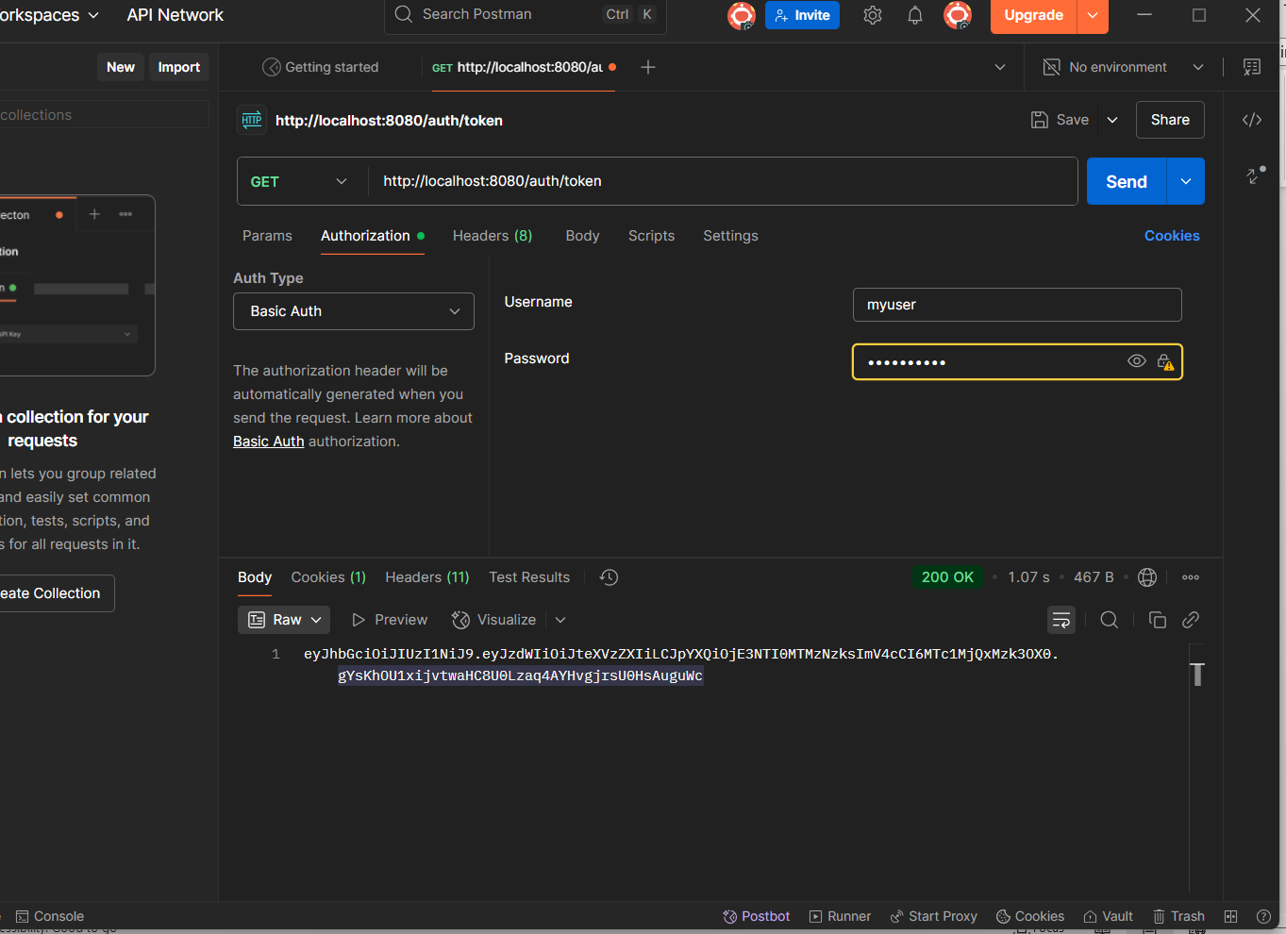

**OUTPUT-CONSOLE**

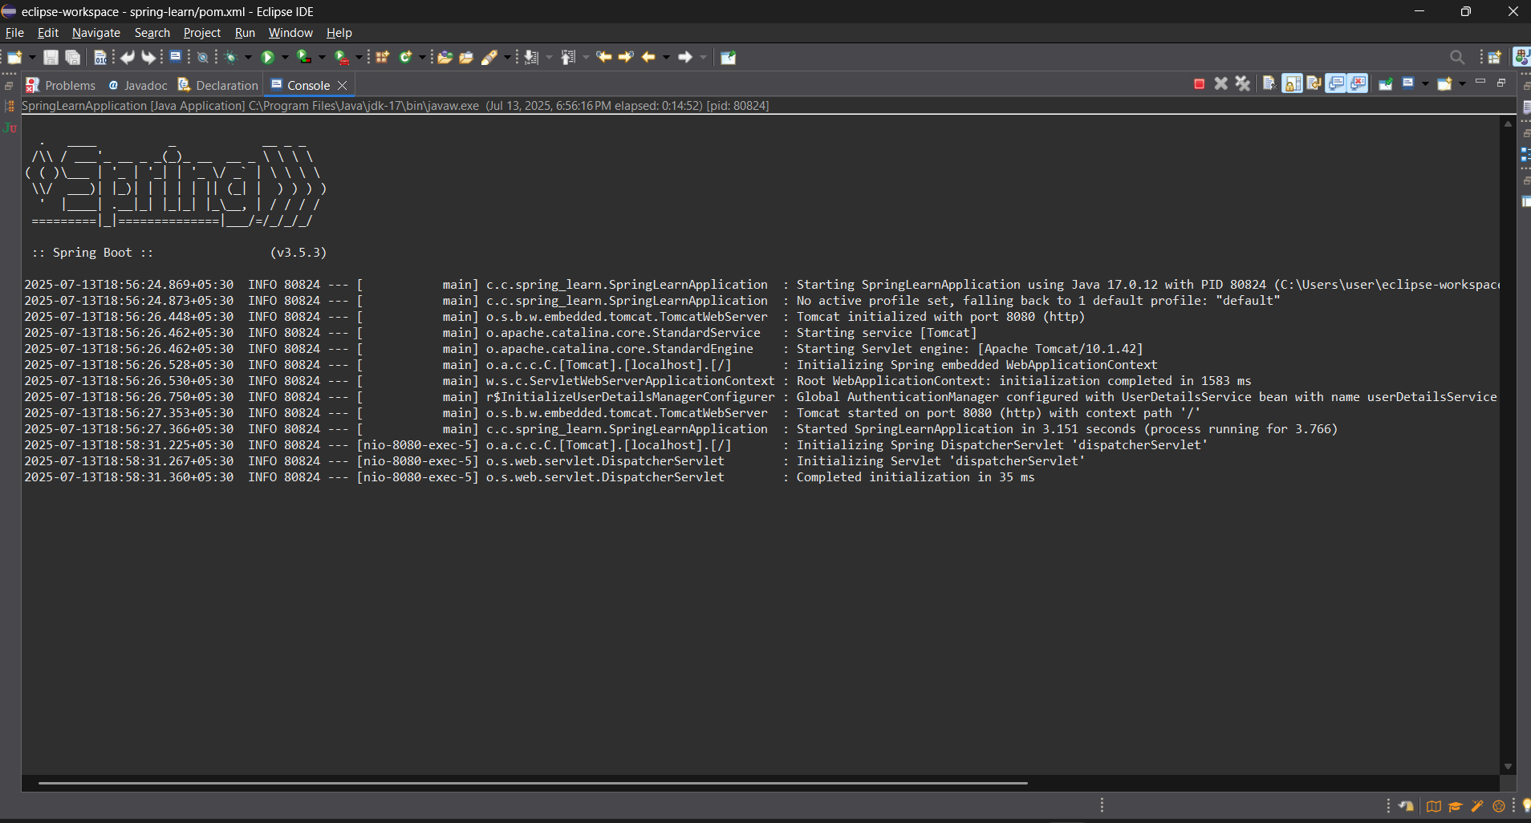

**PROTECTED API TESTING OUTPUT**

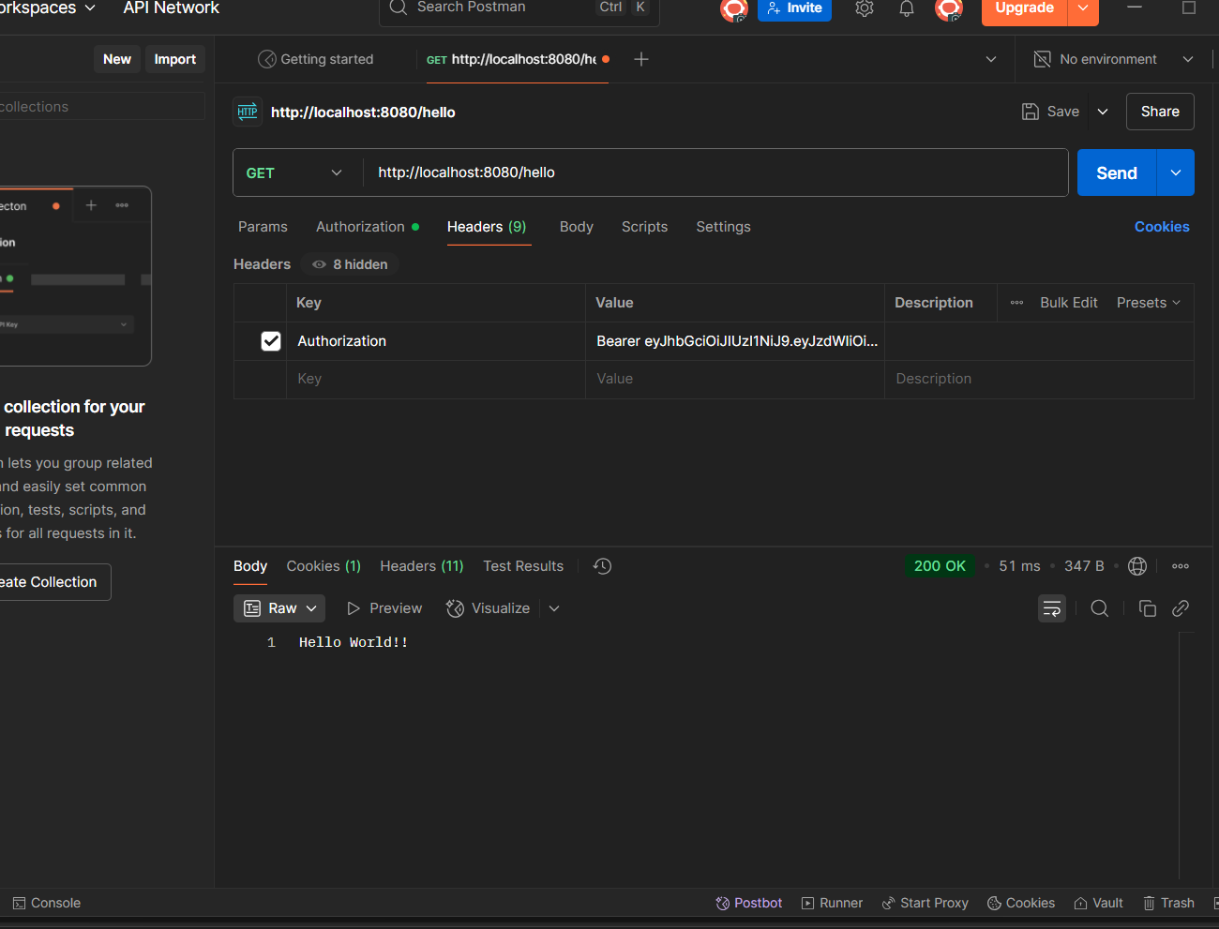

**CONSOLE OUTPUT**

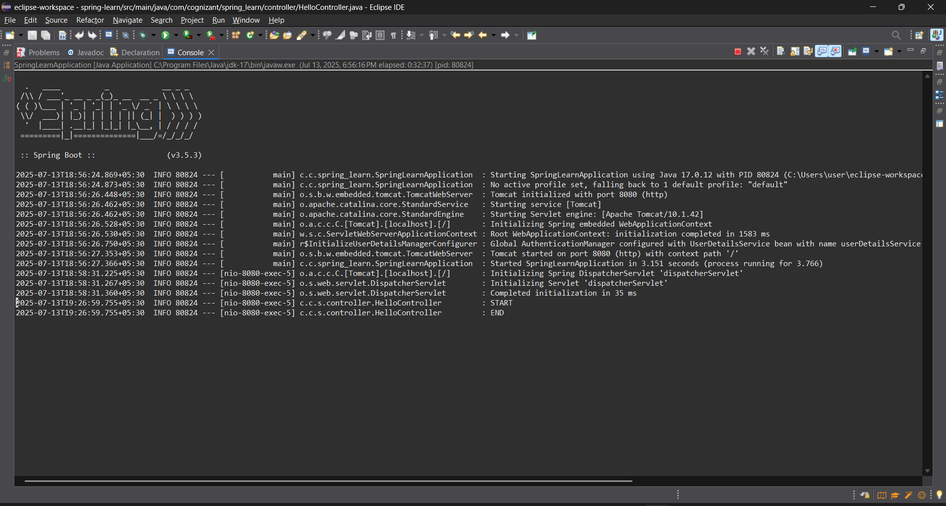

**HelloController.java**

package com.cognizant.spring_learn.controller;

import org.springframework.web.bind.annotation.GetMapping;

import org.springframework.web.bind.annotation.RestController;

*@RestController*

public class HelloController {

*@GetMapping*("/api/hello")

public String hello() {

return "Hello, authenticated user!";

}

}